This document does not describe the process of collecting and inputting data for the PSQ. That is detailed adequately on the rcgp website www.rcgp.org.uk
Viewing the PSQ results
Once they have all been entered, only the educational supervisor of the trainee can view the results.
- Log in as educational supervisor
- Select your trainee
- Click on “evidence” in left hand menu
- Select “PSQ” on the horizontal menu
- Click on the magnifying glass icon next to “summary submissions”
- There you will see the results
After viewing the results, analysing them and making a comment, click “release score to trainee” to enable the trainee and their clinical supervisor/trainer to see them.
The PSQ results will look something like this:

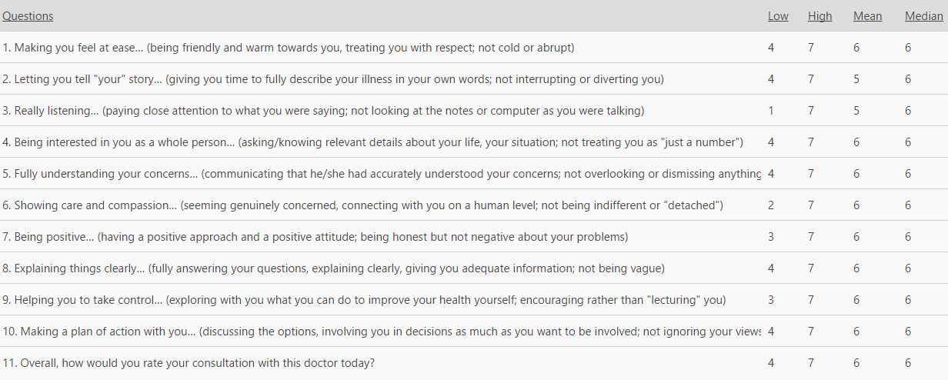

I’ve tried to simplify what the statistics mean on the next 5 pages, referring to the table above. Let’s call this trainee Tim and see if we can work out what his numbers mean. If you are not interested in how the statistics work and you are happy to take my word for it, just go straight to the last page (page 6).
Definitions – trying to understand the terms
Before we can proceed, we need to define and understand what each of these terms mean. On there own, each of these measures can be difficult to interpret as you’ll see from their limitations detailed below. HOWEVER, when you look at them together, they can be pretty enlightening.
MEASURES OF DISPERSION – attempt to assess the spread of a set of observations
Low | The low and the high define the “range” of scores. It is based entirely on the extreme values.  This is not a reliable measure of dispersion, since it only uses two values from the data set. Thus, extreme values can distort the range to be very large while most of the elements may actually be very close together. So, it doesn't tell us anything about the numbers in between. Are most of the numbers close to the minimum, or most close to the maximum? Are the minimum or maximum exceptional?  The reason why it is given though is because if the range is narrow, you can make a good guess that most of the values will be centred around the mean.  (note: another measure of dispersion that you are more familiar with is the standard deviation)
High
MEASURES OF LOCATION – attempt to locate a “typical” value
Mean | The arithmetic mean of a set of values is a sum of all values, divided by their number.  Unfortunately it can be easily affected by extremely large or extremely small values and thus can represent a distorted view of what is “typical”. However, this distortion is less pronounced the larger the data set is.  But the advantage is the mean does take every piece of data into consideration.
Peer Mean | This value tells you how your trainee is doing in relation to an average GP trainee population
Median | The median is simply the middle piece of data, after you have sorted data from the smallest to the largest.  The problem with the median is that it doesn’t take all data into account: it essentially ignores anything that isn’t in the middle!  But it does eliminate the effects of extreme values (and hence tries to achieve a typical value). Thus it is a more stable measure of “typicalness”.
Peer Median | This value tells you how your trainee is doing in relation to an average GP trainee population
- Another measure of location that you may have come across is the “mode” (= the value that occurs most often)
- To some extent, the peer mean and peer median establish the expected level of performance from the trainee

Measures of Central Tendency
Mathematicians refer to a term called “central tendency”; this simply means the typical value the data tends to converge to. There are three measures of central tendency (mean, median, and mode) but the e-portfolio only furnishes you with the mean and median because the mode is less useful as you’ll see below.

How To Interpret the Results?
The mean/median tell you the actual average ‘typical’ score patients gave but how far they can be relied on depends on whether the data collected from the surveys, as a whole, is skewed or not.
The trainee can have data that
- follows a normal distribution (ie a symmetrical bell shaped distribution that the clever one’s amongst you will recall the term Gaussian)
- is skewed – where one side of the slopes tapers off
In a normal distribution, the mean and median lie bang in the middle of the bell shaped curve and thus represent true reflections of what is the “typical” score that patients gave. Thus, in a normal distribution, the mean, median, and mode are all the same value and can be relied upon.
However, in a skewed distribution, the mean will either underestimate or overestimate what it regards as typical. Thus, in asymmetrical distributions the mean and median are not the same and may not reflect a true measure of ““typicalness”” because more than half the scores are either above or below the mean (as better illustrated in the diagrams below).
normal distribution
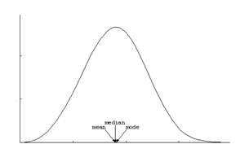
Interpretation: the trainee’s mean and median score are the same and thus are good measures of ““typicalness””
distribution skewed to left
If the median is greater than the mean, the data set is skewed to the left (data having upper limit but no lower limit will result in negatively skewed to the left).
Interpretation: the trainee’s mean score may not reflect “typicalness” and actually (s)he might have got higher typical marks because more than 50% of the scores are above the mean.
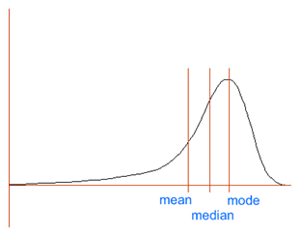

distribution skewed to right
If the median is less than the mean, the data set is skewed to the right (i.e., data having lower limit but not upper limit will result in positively skewed to the right).
Interpretation: the trainee’s mean score may not reflect “typicalness” and actually (s)he might have got lower typical marks because more than 50% of the scores are lower the mean.
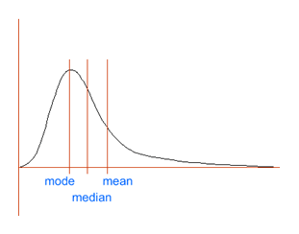
A Rule To Remember: As you can see from the graphs above, in any skewed distribution (i.e., positive or negative) the median will always fall in-between the mean and the mode (mode remember is the commonest value). The greater the difference between the mean and median, the greater the skew. For a right skewed distribution, the mean will always be the highest estimate of “typicalness” and the mode will always be the lowest estimate. For a left skewed distributions, the mean will always be the lowest estimate of “typicalness” and the mode will be the highest estimate.
What Does All This Mean Practically?
For each criterion:
- Work out the range: in our case above, looking at the first criteria, Q1, Tim’s range is 4-7: in other words one or more patients gave him a score of 4 (=good) and one or more patients gave him a score of 7 (=outstanding) and the rest somewhere in between. The limitation of the range is that it doesn’t tell you how many scored him in the 4 to 5 range nor how many scored him with a 6 or 7. He could have got one 4 and forty 7s (41 questionnaires were submitted). This is where the other values come in handy. Note that a narrow range indicates that the data is closely centred around the mean; therefore, the mean is a good representative of the data set. Tim’s range is pretty narrow (4-7). On the other hand, a large range indicates that the mean might not be a good representative of the data set and MIGHT indicate inconsistent performance.
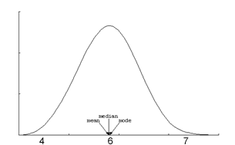
- Now look at the mean and the median: to get an idea of how skewed or not the distribution is. There are three possible outcomes:
- If the mean = median: the trainee results follow a normal bell shaped distribution and they reflect a true measure of “typicalness”.
In Tim’s case, looking at Q5 “fully understanding your concerns”; his range was still 4-7 (narrow); his mean was 6 and his median was 6 – see picture on the right. You can see he follows a normal distribution and thus can conclude that the typical patient score was 6. But remember, if the median and mean are the same, that doesn’t mean the trainee did well. It just means that it is a good measure of “typicalness”; the absolute value of them tells you how well they did.
Actually, this was Tim’s tally chart (you can see our guess was roughly on track).
1 | 2 | 3 | 4 | 5 | 6 | 7
0 | 0 | 0 | 2 | 7 | 18 | 13

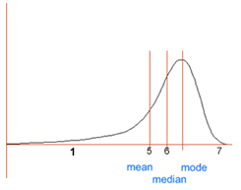
- If the mean < median: the trainee’s result are skewed (the larger the difference, the greater the skew) with the slope tapering off more slowly to the left (the lower scores). In Tim’s case, looking at Q3 “really listening”; his range was 1-7; his mean was 5 but his median was 6; so we can now picture the following:
You can see that more than 50% of the scores were above the mean of 5 so actually Tim’s typical score was probably higher than 5 (probably 6; as the median score states).
Actually, this was Tim’s tally chart (you can see our guess was roughly on track).
1 | 2 | 3 | 4 | 5 | 6 | 7
1 | 1 | 2 | 1 | 7 | 19 | 10

- If the mean>median: the trainee’s result are skewed (the larger the difference, the greater the skew) with the slope tapering off more slowly to the right (the higher scores)
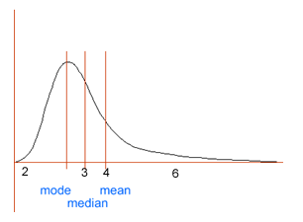
In Tim’s case, we don’t have an example of this. In Q6 his range was 2-6 but if his mean was 4 and his median was 3; we would then be able to infer the following:
You can see that more than 50% of the scores were below the mean of 4 so actually (in this fictitious example) Tim’s typical score was probably lower than 4 (probably 2 or 3; as the median score states).
You might have deduced from Tim’s example above that as distributions go from symmetrical to more skewed (ie the median and mean become separated), you should choose the median over the mean as a measure of “typicalness”.

In Summary
- Look at the range
A narrow range indicates that the data is closely centred around the mean; therefore, the mean is a good representative of the data set.
A large range indicates that the mean might not be a good representative of the data set and MIGHT indicate inconsistent performance.
- Now look at the mean and median to get an idea of whether the mean/median is reliable and which one to use
If mean = median | The mean/median scores reflect what the trainee typically got
If mean < median | The mean UNDER estimates the typical score. The typical score the trainee got was more than what the mean states. Use the median value.
If mean > median | The mean OVER estimates the typical score. The typical score the trainee got was less than what the mean states. Use the median value.

- Don’t forget the rules of feedback when giving back and discussing these results.

Feedback gratefully received: mail me on rameshmehay@googlemail.com

